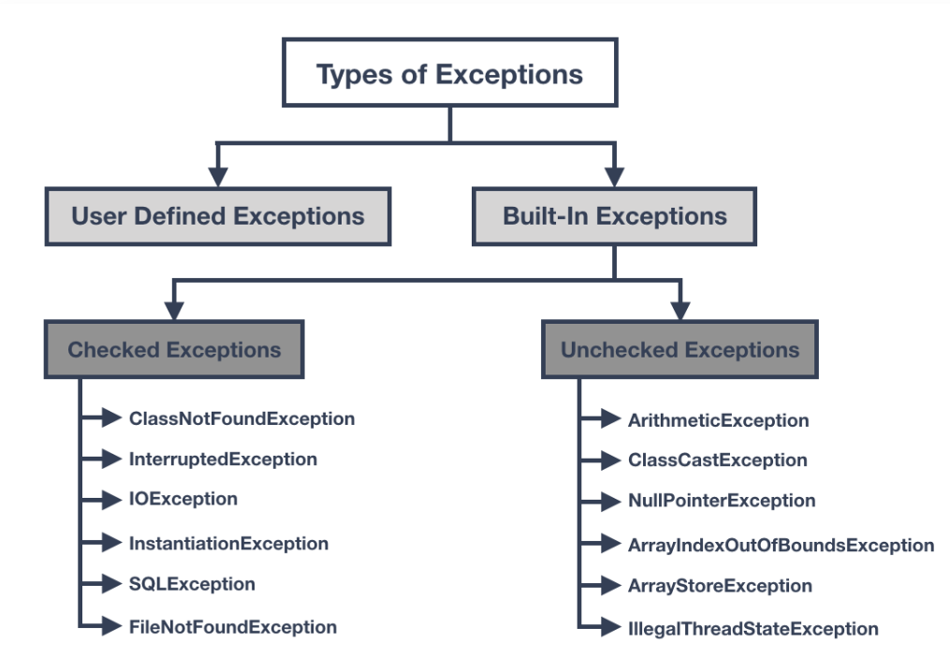

https://rollbar.com/blog/how-to-handle-checked-unchecked-exceptions-in-java/#:~:text=Difference%20Between%20Checked%20and%20Unchecked%20Exceptions%20in%20Java,-To%20summarize%2C%20the&text=unchecked%20exception%20is%3A-,A%20checked%20exception%20is%20caught%20at%20compile%20time%20whereas%20a,t%20required%20to%20be%20handled.